Amazon A2I – Amazon Augmented AI
Amazon Augmented AI (A2I) is a managed service from Amazon Web Services that enables human-in-the-loop machine learning. It allows you to automatically route uncertain or sensitive predictions from ML models to human reviewers for validation and correction.
A2I works by integrating with ML services such as Amazon Textract, Amazon Rekognition, or custom models built using Amazon SageMaker. When a model produces a result, A2I evaluates it based on predefined conditions (like low confidence scores or specific business rules). If the condition is met, the task is sent to a human review workflow, where reviewers verify or correct the output. The final validated result is then returned.
The service provides prebuilt workflows for common tasks (e.g., text extraction, content moderation) and also supports custom workflows tailored to specific applications. It offers flexibility in choosing the workforce, including private teams, third-party vendors, or crowd workers.
The main advantages of A2I are improved accuracy, better compliance in critical applications, and reduced effort in building manual review systems. It is widely used in areas like document processing, content moderation, and industries requiring high reliability such as finance and healthcare.
In short: A2I enhances machine learning systems by combining automated predictions with human judgment to ensure more accurate and trustworthy results.
How It Works
A2I uses a HumanLoop to manage the process:
- Prediction: An ML model makes a prediction.
- Evaluation: A2I evaluates if the prediction meets a set confidence threshold.
- Human Review: If the confidence is low, the data is sent to a human worker, who uses a web interface generated by A2I.
- Consolidation: The human-reviewed result is sent to the output destination
Key Features & Benefits
- Built-in Workflows: Provides pre-built human review templates for common use cases like document processing, image moderation, and text extraction.
- Confidence Thresholds: Automatically routes low-confidence predictions to human reviewers, reducing unnecessary manual review.
- Flexible Workforce: Allows use of internal employees, third-party vendors, or the public Amazon Mechanical Turk marketplace.
- Integration: Works with Amazon SageMaker, Amazon Rekognition, Amazon Textract, and custom models.
Use Cases
- Document Processing: Verifying PII (Personally Identifiable Information) redaction or extracting data from forms.
- Content Moderation: Reviewing images or text for inappropriate content.
- Compliance & Accuracy: Ensuring high-stakes decisions in finance or healthcare meet accuracy standards

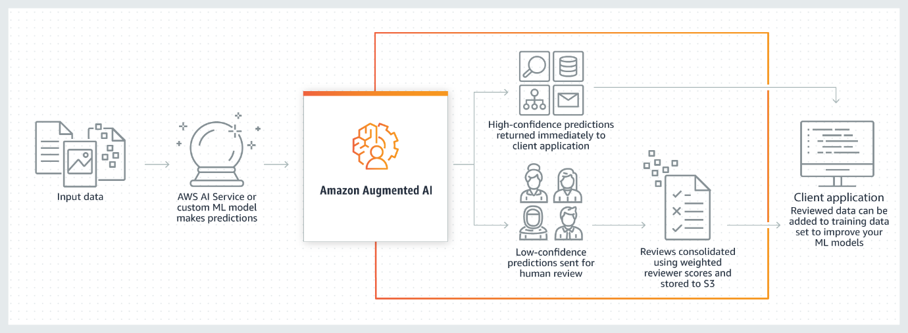
What is Amazon Augmented AI?
Amazon Augmented AI (Amazon A2I) is a service that brings human review of ML predictions to all developers by removing the heavy lifting associated with building human review systems or managing large numbers of human reviewers.
Many ML applications require humans to review low-confidence predictions to ensure the results are correct. For example, extracting information from scanned mortgage application forms can require human review due to low-quality scans or poor handwriting. Building human review systems can be time-consuming and expensive because it involves implementing complex processes or workflows, writing custom software to manage review tasks and results, and managing large groups of reviewers.
Amazon A2I streamlines building and managing human reviews for ML applications. Amazon A2I provides built-in human review workflows for common ML use cases, such as content moderation and text extraction from documents. You can also create your own workflows for ML models built on SageMaker AI or any other tools. Using Amazon A2I, you can allow human reviewers to step in when a model is unable to make a high-confidence prediction or to audit its predictions on an ongoing basis.
Amazon A2I Use Case Examples
The following examples demonstrate how you can use Amazon A2I to integrate a human review loop into your ML application. For each of these examples, you can find a Jupyter Notebook that demonstrates that workflow in Use Cases and Examples Using Amazon A2I.
- Use Amazon A2I with Amazon Textract – Have humans review important key-value pairs in single-page documents or have Amazon Textract randomly sample and send documents from your dataset to humans for review.
- Use Amazon A2I with Amazon Rekognition – Have humans review unsafe images for explicit adult or violent content if Amazon Rekognition returns a low-confidence score, or have Amazon Rekognition randomly sample and send images from your dataset to humans for review.
- Use Amazon A2I to review real-time ML inferences – Use Amazon A2I to review real-time, low-confidence inferences made by a model deployed to a SageMaker AI hosted endpoint and incrementally train your model using Amazon A2I output data.
- Use Amazon A2I with Amazon Comprehend – Have humans review Amazon Comprehend inferences about text data such as sentiment analysis, text syntax, and entity detection.
- Use Amazon A2I with Amazon Transcribe – Have humans review Amazon Transcribe transcriptions of video or audio files. Use the results of transcription human review loops to create a custom vocabulary and improve future transcriptions of similar video or audio content.
- Use Amazon A2I with Amazon Translate – Have humans review low-confidence translations returned from Amazon Translate.
- Use Amazon A2I to review tabular data – Use Amazon A2I to integrate a human review loop into an ML application that uses tabular data.

Links:
- https://docs.aws.amazon.com/augmented-ai/#:~:text=Amazon%20Augmented%20AI%20(Amazon%20A2I,large%20numbers%20of%20human%20reviewers.

